***Original Article***

Image Classification using Deep Learning (DL)

**Parivesh Sood1, Fancy C2**

***1,2****Department of Networking and Communications, School of Computing, College of Engineering and Technology, SRM Institute of Science and Technology, Potheri, Kattankulathur 603203, Chengalpattu District, Tamil Nadu, India*

[*2fancyc@srmist.edu.in*](mailto:2fancyc@srmist.edu.in)

Received: Revised: Accepted: Published:

***Abstract -*** *Car number plate recognition system is a real time system that automatically detects the number plate from a vehicle and extracts the alphanumeric characters from the license plate, i.e the license number of the vehicle. There are various methods of extracting numbers from the plate. In this paper we have made the use of data processing tools like morphological transformation, and gaussian smoothing/thresholding, and edge detection in the pre-processing part. After which for the plate segmentation, contours are used and filtered based on character dimensions and location. At last, we have used Optical Character Recognition to recognize the extracted characters from the data*

***Keywords:*** *Car number plate, Contours, Computer Vision, Python, Libraries*

**1. Introduction**

The research world today is moving at a very fast pace, there is one or the other research today on various topics. Our project titled “Image Classification using Deep Learning” focuses on clearing the problem of car number recognition from the number plate. Car number plate recognition system uses free to use software including python with its various libraries such as the Open Computer Vision, TensorFlow, Numpy, etc. With the rise of a number of free and open-source technologies, the computing world is blessed with a whole lot of new opportunities. One of the many such boons is Python.

**2. Proposed System**

***2.1. Image Capturing***

The image of the car is captured using a high-resolution photographic camera or an infrared camera. The input image is shown in Figure 1.

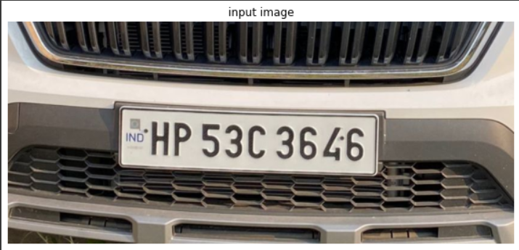

**Figure 1 Input Image.**

***2.2. Plate Detection***

The input image is changed from RGB to gray scale colorspace for easy detection of the number plate. The number plate is detected by drawing rectangles around the numbers and the detected number plate is displayed for user’s understanding, as shown in Figure 2.

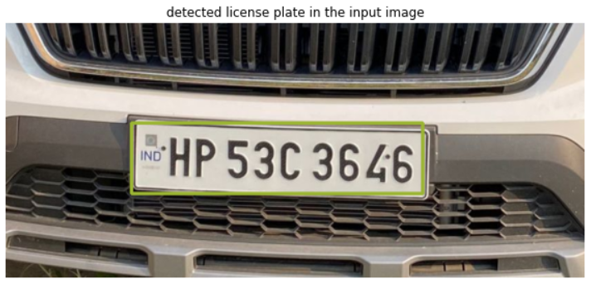

**Figure 2 Detected License Plate.**

***2.3. Matching Contours***

All the contours are searched for in the image and the potential dimensions are retrieved. The largest 5 and 15 contours are checked for number plate and characters respectively. Then the contours are detected in the binary image and the coordinates for the rectangle around it are returned. Each character is further extracted using the rectangle’s contours. The image is resized to 24*44 with black border. The character’s binary image is stored and returned in ascending order. The characters are given an index each and the characters are further stored in accordance to the respective indices.

***2.4. Character Segmentation***

The cropped car number plate image is pre-processed again, i.e., resizing, change of the colorspace, etc. Furthermore, the morphological operations are applied, the border colour is changed to white. And the estimations of character contours for cropped license plate are done. The segmented characters from the number plate are returned as shown in Figure 3.

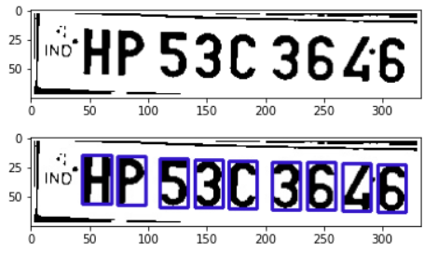

**Figure 3 Character Segmentation on the plate.**

***2.5. Model Building***

A sequential model is created with convolution kernel convolves with input or previous layers. The down sampling and flattening of the input are done, and the parameters are defined. The model details are given in Figure 4.

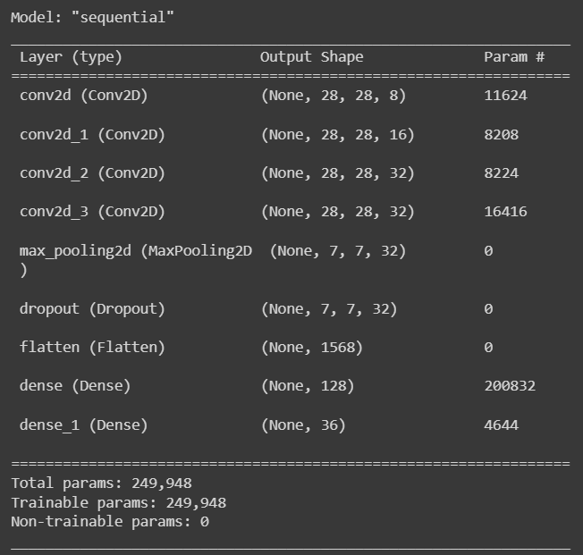

**Figure 4 Model Details.**

The model is trained and the next step is to print the extracted text and to show the predicted and actual values together.

**2.6. Final Predictions**

The final results are shown here with the predicted as well as the actual values below them to check the accuracy of the model. The final segmented result as given by this model can be shown in Figure 5.

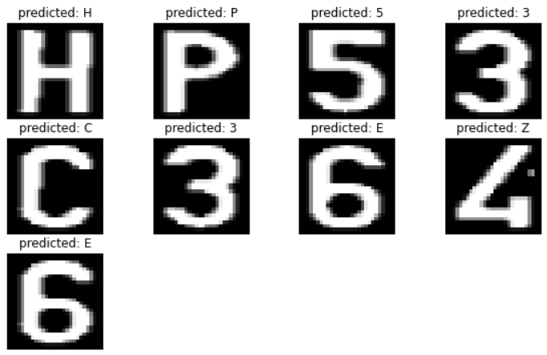

**Figure 5 Final Predicted Output.**

**3. Results and Discussion**

The message of this research project is to show that free and open-source technologies are good enough to be used in scientific computing domains. The system works satisfactorily for a wide variety of illumination conditions and different types of number plates commonly found in India. It can be a better alternative to many of the existing proprietary systems in the Indian market space, even though there are known restrictions of my project.

**4. Conclusion**

Car number detection from number plate applications are increasing day by day in the Indian arena, since there has been a steep and phenomenal increase in the number of cars, bikes, auto and industry vehicles. Automatic car number detection can be used in various applications including toll collection, mall parking spaces, even manage vehicle in parking spaces, and it can also be included in traffic cameras to monitor and regulate traffic rules violations etc. This was developed in Google Colab using optical character recognition by taking images as input from computer. Character segmentation was used to extract every number from the number plates. Finally, F1 score precision, recall was found for the input image and the result was calculated.

**Conflicts of Interest**

The author(s) declare(s) that there is no conflict of interest regarding the publication of this paper.

**Funding Statement**

This project was self-funded and no monetary grant was received via any person, group or organization in completing the project.

**Acknowledgments**

I would like to thank my guide and mentors, my friends and family for all the support in completion of this project.

**References**

1. A. Gordon, License plate recognition technology: innovation in

law enforcement use, Thomson Gale Press, 2007.

1. Recognising a new way to keep traffic moving, Siemens, Traffic April 2005, 1-12.
2. Website, Available: [http://www.ipcamerachina.com/CCTV-Camera-Se](http://www.ipcamerachina.com/CCTV-Camera-Se-)ries/LPR-ANPR-Camera/index.html.
3. Website, Available: [http://www.vitronic.de/en/traffic-technology/alpr/.](http://www.vitronic.de/en/traffic-technology/alpr/)
4. Website, Available: <http://www.leutron.com/>Leutron Vision.
5. Website, Available: <http://x.htsol.com/index.php?action=1&k=4&sub=30> Hi-Tech Solutions.
6. C.Hoare, Communicating Sequential Processes, Prentice Hall, 1985, updated 2004.
7. M. Barr, Introducing to Rate-Monotonic Scheduling; Embedded Systems Programming; [www.embedded.com,](http://www.embedded.com/) 2001.
8. D. Pellerin, The Microsoft Win32 Programming Model: A Primer for Embedded Software Developers, MSDN Microsoft Corporation, 1998.
9. A. Atanassov, Process-oriented Approach to Control Interface Communications of Automated Parcels’ Processing Systems, Journal Automatics & Informatics 4, Sofia, 2009, 46-53.
10. Harpreet Kaur, M. B. (Nov-2012). VEHICLE LICENSE PLATE DETECTION FROM EDGE DETECTION AND MORPHOLOGICAL OPERATORS. International Journal of Engineering Research & Technology (IJERT) ISSN:2278-0181 Vol.1 Issue 9.
11. K Sudha Rani, D. N. (2018). A COMPARATIVE STUDY OF VARIOUS NOISE REMOVAL TECHNIQUES USING FILTERS. Journal of Engineering and Technology.
12. Kim, K.K., Kim, K.I., Kim, J.B. and Kim, H.J., 2000, December. Learning-based approach for license plate recognition. In Neural Networks for Signal Processing X. Proceedings of the 2000 IEEE Signal Processing Society Workshop (Cat. No. 00TH8501) (Vol. 2, pp. 614-623). IEEE.
13. Han, C.C., Hsieh, C.T., Chen, Y.N., Ho, G.F., Fan, K.C. and Tsai, C.L., 2007, October. License plate detection and recognition using a dual-camera module in a large space. In 2007 41st Annual IEEE International Carnahan Conference on Security Technology (pp. 307-312). IEEE.
14. Mondal, M., Mondal, P., Saha, N. and Chattopadhyay, P., 2017, December. Automatic number plate recognition using CNN based self-synthesized feature learning. In 2017 IEEE Calcutta Conference (CALCON) (pp. 378-381). IEEE.
15. Agbemenu, A.S., Yankey, J. and Addo, E.O., 2018. An automatic number plate recognition system using opencv and tesseract ocr engine. International Journal of Computer Applications, 180, pp.1-5.
16. Laroca, R., Severo, E., Zanlorensi, L.A., Oliveira, L.S., Gonçalves, G.R., Schwartz, W.R. and Menotti, D., 2018, July. A robust real-time automatic license plate recognition based on the YOLO detector. In 2018 International Joint Conference on Neural Networks (IJCNN) (pp. 1-10). IEEE.
17. Dhar, P., Guha, S., Biswas, T. and Abedin, M.Z., 2018, February. A system design for license plate recognition by using edge detection and convolution neural network. In 2018 International Conference on Computer, Communication, Chemical, Material and Electronic Engineering (IC4ME2) (pp. 1-4). IEEE.
18. Lin, C.H. and Li, Y., 2019, August. A License Plate Recognition System for Severe Tilt Angles Using Mask R- CNN. In 2019 International Conference on Advanced Mechatronic Systems (ICAMechS) (pp. 229-234). IEEE.
19. Saif, N., Ahmmed, N., Pasha, S., Shahrin, M.S.K., Hasan, M.M., Islam, S. and Jameel, A.S.M.M., 2019, October. Automatic License Plate Recognition System for Bangla License Plates using Convolutional Neural Network. In TENCON 2019-2019 IEEE Region 10 Conference (TENCON) (pp. 925-930). IEEE.
20. Sourav Roy, Amitava Choudhury, Joydeep Mukherjee.,” An Approach towards Detection of Indian Number Plate from Vehicle”International journal of Innovative Technology & Exploring Engineering(IJITEE)Volume-2, Issue-4, March 2013.
21. Phalgun Pandya, Mandeep Singh, “Morphology based Approach to Recognize Number Plates in India”, IJSCE, Vol.1, Issue 3, 2011, pp1 07-112.
22. Ch. Jaya Lakshmi, Dr A.Jhansi Rani, Dr. K. Sri Ramakrishna, M.Lantikiran, V.R. Siddhartha,”A novel Approach for Indian License Plate Recognition System”, IJAEST, Vol 2 Issue I, 2011, pp 010-014.
23. Zhigang Xu, Honglei Zhu, “An Efficient Method of Locating Vehicle License Plate”,IEEE 2007.
24. S. H. Kasaei .,S. M. Kasaei, " Extraction and Recognition of the Vehicle License Plate for Passing Under Outside Environment." IEEE 2011.